U04692 Project

*Interim Report*

|  |  |
| --- | --- |
| *Project Title* | Mechanical Radial Error Correction |
| *Module Number* | UO4692 |
| *Programme* | Computer aided Mechanical Design |
| *Student Name* | Marc Hudson |
| *Student Number* | 07089704 |
| *Supervisor Name* | Khaled Hayatleh |
| *Date of Submission* | 24-12-2013 |
| *Word Count* | 6499 |

Department of Mechanical Engineering and Mathematical Sciences

2013-14

# Table of Contents

|  |  |
| --- | --- |
| Page Number | Content |
| 3 | List of Figures |
| 4 | List of Symbols and Abbreviations |
| 5 | Introduction |
| 6 | Aims & Objectives |
| 7 | Industrial relevance |
| 8 | Project Summary |
| 9 | Project Summary |
| 10 | Literature review - Introduction |
| 11 | Literature review - Existing Products and Technology |
| 12 | Literature review - Existing Products and Technology |
| 13 | Literature review - Design difficulties & simultaneous tuners |
| 14 | Literature review - Design difficulties & simultaneous tuners |
| 15 | Literature review - Feedback & Motors + Summary |
| 16 | Methodology - Introduction |
| 17 | Methodology - Software selection |
| 18 | Methodology - Communications between hardware and software |
| 19 | Methodology - Communications between hardware and software |
| 20 | Coding the Arduino board |
| 21 | Coding the Arduino board |
| 22 | Coding the Arduino board |
| 23 | Methodology - Summary |
| 24 | Methodology - Summary / timing plan contingency |
| 25 | Work in progress / Work completed |
| 26 | Work in progress / Work completed |
| 27 | Work in progress / Work completed |
| 28 | Work in progress / Work completed |
| 29 | Work in progress / Work completed |
| 30 | Timing Plan / Gantt Chart |
| 31 | Revised Timing Plan / Gantt Chart |
| 32 | Summary |
| 33 | References |
| 34 | Bibliography |
| 35 | Appendices |
| 36 | Appendices |

# List of Figures

# 

# List Of Symbols and Abbreviations

* IDE Integrated Development Environment
* PDS Product Design Specification
* C++ Programming Language
* RS232 Serial communication
* OEM Original Equipment Manufacturer
* SMART Specific, Measureable, Achievable, Relevant, Time-bound

1. **Introduction**

This is a project in which the technologies behind the methods used to correct radial position error will be explored, evaluated and put into practice. Error correction is an important part of any closed-loop system; it is used frequently in many electro-mechanical systems. To outline the purpose and use of error correction; it is used to ensure a required output will match a user, or application defined reference. This is done through comparing the system output with the reference, and adjusting until the error between the reference and output is corrected. In short, the system will automatically adjust to the desired position.

Amongst other things, applications of such a technology are commonly found in stepper motor control, robotics, avionics, and things like temperature controls. A basic, yet well-known application of error correction would be in a household thermostat. In this example the house is being heated until the user defined temperature is met, at which point the boiler clicks off. This is achieved through a closed loop system, which is continually checking the temperature against what the user desired in the first place.

This project specifically will focus on the rotational control of a shaft in a particular application. For this, the same theory is applied regarding the correction of error until a desired position is achieved. This time however, in order to achieve the correct position, the system will be relying on inputs of a different nature to those mentioned in previous examples. For this project, the system will be making adjustments according to either frequencies picked up by a microphone, through vibration or from a direct signal from the instrument.

The project will be to make a unique automatic tuner for a guitar where user input is not required. A system which takes the frequencies produced by playing a guitar string, makes an assumption of which pitch the string is supposed to be, and rotates the shaft of the machine head (tuning knob) until the desired pitch is met.

**Aim and OBjectives**

The objective of the project is to design and build an electro-mechanical system which can automatically tune an electric guitar. For now this is the main aim, however, as the project goes on, it’s expected that further features will be implemented into the project in order to increase functionality and ease of use.

**SMART Objectives**

**Specific:**

The project will succeed in making the process of tuning a guitar easier AND quicker than tuning each machine head by hand. And will be to a required standard of accuracy which can be measured.

**Measurable:**

The performance of the product can be observed and measured. The tuner must be able to rotate the shaft until the reference pitch is achieved. This will be later compared with human perception and explained as to what accuracy is considered acceptable by the end user.

**Achievable:**

With the resources available from the university and the amount of time allocated. This project is achievable and will be completed within the set time.

**Relevant:**

The relevance of this project is without question. The technology, although available, is rarely applied to this application. Other products that attempt this are unreliable and professionals in the industry refer back to manual tuning as a result.

**Time-bound:**

This project will be completed by 23rd April 2014. The product itself and all the documentation will be completed and submitted by this date.

**INDUSTRIAL and RESEARCH Relevance**

In choosing this project, it was of utmost importance to find something for which there was a genuine need in the industry. This is for two reasons; first of which is that designing and manufacturing such product can assist in the daily work of technicians in the industry, secondly, the project could become a viable product to put on the market in the future.

The project itself is to explore the technology involved in accurately controlling rotation of a shaft. The technology behind error correction using closed loop systems is already commonly used in a multitude of applications. However, this application is more unique as the aim of this project is to produce an automatic guitar tuner. From Internet research, there are few professionally produced units that have the ability to tune a guitar automatically. From research into these products, they’re not without their pitfalls. The aim of this project is to design and manufacture a simplistic, ergonomic and accurate guitar tuner, which is easier to use than those on the market.

From having 3 years in the industry it can be said that the necessity of this product is without question. At the top-end of the industry when artists business is lucrative and they are performing regularly, it is considered standard practice to employ a technician who is responsible for keeping all instruments in tune and in working order. That being said, depending on the success of the performer in question, they can have upwards of 10 technicians depending on the complexity of the stage production and technology used. To put the scope of the work involved in perspective, even for a lower-budget stage production, there may be 6 guitar changes in one performance. Each time, the guitar needs to be tuned. Further to this, each time a guitar string breaks or the guitar needs to be re-strung; all the strings need to be tuned. Most guitars have 6 strings, so the amount of time spent maintaining the tuning quickly becomes a difficulty.

In the case where there is for example 1 or 2 technicians, the necessity of this product really becomes apparent. An automatic tuner not only will save the technician significant amounts of time, but it will also eliminate human error in the tuning process.

Industry standard guitar tuners range from having a 6.3mm jack input to having a clip-on capability to detect string vibration from the body of the guitar. These tuners typically display a range of frequencies in which the string pitch should be within. The task of the technician is to look at the screen and manually rotate the machine heads of the guitar until the pitch is achieved. Understandably, this process can be time consuming and the process is exposed to a high likelihood of human error. The project when in it’s completed state will eliminate these difficulties and make the job easier for technicians and musicians alike.

**Summary**

In summary, as long as the project plan is followed, the project will be completed well within the time constraints and the project will meet all aspects of the Product Design Specification. All of the technology is available and the resources required are within the confines of the university so it should be a simple task to acquire everything needed to manufacture both the prototype version of the project, and later, the final design. Extra time was allocated in the ‘design validation’ stage in order to correct bugs in the software and hardware. It’s important when reviewing progress to allow extra time in case extra developments can be made that may not have been planned in the beginning. I.e. from spending 4 days in the laboratory, extra functions could be implemented, making the product work in a more efficient way / having more functionality.

Also included in the project plan is the detail regarding the project write-up. Although it’s not related to the manufacture of the project, it’s important not to lose sight of the fact that the documentation is almost more important than the physical end product. This is because the journey from the concept stage through all the inevitable problems to the end result will make for useful reading if any future student / engineer wishes to review this project to help with something of their own.

The relevance of the project has been established and the need for such a device in the industry is apparent. Therefore every effort will be made for the project to be well-engineered, functional, easy to use and erganomic for the end user. The literature search will prove it’s worth upon researching both the methods used for error correction, and on the mechanical side, what is torque is required to tune the machine head of any guitar. From initial reading, it’s clear this project is going to be very in-depth with a lot of challenges to overcome.

**2 literature review**

**2.1 INTRODUCTION**

In order for any project to be comprehensive, it’s important to review previous literature on the topic. The following textbooks were initially reviewed for information on the topic of mechanical radial error correction, before the project was underway:

# Djaferis, Theodore Euclid. (1998). *Automatic control: the power of feedback using MATLAB.* Boston : PWS Publishing.

# Phillips, Charles L; Harbor, Royce D.(2000). *Feedback control systems*. 4th Edition. London : Prentice-Hall

* Dorf, Richard C. (Richard Carl). (1998). *Modern control systems.* 8th ed. Harlow : Addison-Wesley

Further to this, there are two previous projects completed at Oxford Brookes University, which discuss the uses of both DC motors and the programming of an Arduino board. For this project, the initial prototypes will be made using an Arduino, so this literature is important for research.

* Rizwan, Mohammad. (2009). Controlling air driven motor with Arduino board. Beng Thesis. Oxford Brookes university.
* Newton, James Leonard. (2012). *Controlling a brushless motor.* BSc Thesis. Oxford Brookes University.

In addition to books and previous student projects from the university, It’s also important to review online journals for relevant information. As this project is electro-mechanical, both the circuitry / programming side and the motor side need to be researched. Below are 3 engineering journals, and in addition, one technical paper on motion control.

* Ziegler, J.G., and Nichols, N.B.(1942), Transactions of the American Society of Mechanical Engineers (ASME). *Optimum Settings for Automatic Controllers* v. 64, pp. 759-768.
* Nehal M. Elsodany, Sohair F. Rezeka, Noman A. Maharem. (2010). Adaptive PID control of a stepper motor driving a flexible rotor. *Alexandria Engineering Journal*. 50. Pp.127-136
* Adamu Murtala Zungeru and Mahmud Shehu Ahmed. (2012). *Development of a duel heater control system.* Vol.2, No.4. pp 16-23.

**Additional technical paper**

* Dr. Stephen J. O’Neil. (1998). *Motion control handbook*. Pp. 1-38.

**2.2 Existing projects & technology**

Although it’s important to include the aforementioned literature, since beginning working on the project, new literature had came into light from doing additional research. The following thesis was found to be much more relevant than the previous literature. It originates from a university in Austria, and the project is exploring much the same technology as this project.

* Viehauser, M; Weißensteiner. R. (2012). *Motorized guitar tuner*. Telematics. Graz, University of Technology. Dipl. Ing: 112.

Weißensteiner and Viehauser have designed a motorised guitar tuner and the thesis documents every step of the process. The document is very comprehensive in it’s nature and details the difficulties involved from frequency detection / manipulation, all the way to the hardware and servo control.

The project shows the use of an ATMEL Mega32 μ-Controller, whereas a micro Arduino board was chosen for this project. The Arduino contains this microcontroller but also has all the supporting electronics, inputs and outputs, LEDs and ‘reset’ button built in. The main reason for the choice of using an Arduino board is that it has all the functions required and is something used frequently at Oxford Brookes University.

To extract useful information from the literature research, it can be said that ‘Motorized guitar tuner’ (Viehauser, M; Weißensteiner. R. 2012) demonstrates that a project of this nature has been undertaken before, and with great success. That being said, their thesis will be used as a reference point for this project, but nothing more. There are significant differences between the two projects, which need to be noted:

* Different programming language used
* Different hardware – programmable micro controller
* Completely different housing design
* Difference in ergonomics
* Difference in user inputs required.

The three last points are essential to this project. From looking at the literature it can be seen that the design direction is different between their thesis and this project. The priority of this project – after all the functionality is achieved – is to manufacture something that would be easily used, and very accessible to professionals and amateurs alike. In order to achieve this, the goal is to have a product where there is minimal user input. i.e. very few buttons or settings – something which can be picked up and used with minimal effort or understanding and then put down. Figure 1 shows the guitar tuner manufactured by Weißensteiner and Viehauser.

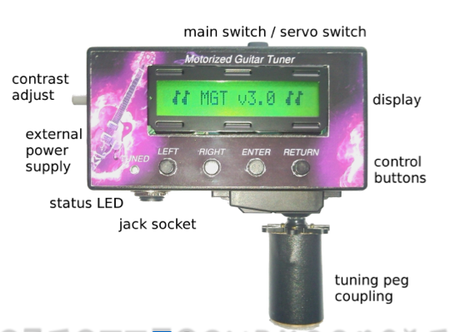

Figure 1 ‘Motorized guitar tuner’

* 1. **Design difficulties with existing products**

From researching into the above project, some difficulties have become apparent. From finding out these difficulties, the objective would be to design the product with these pitfalls in mind, in an attempt to rule them out. In the conclusion of the ‘motorized guitar tuner thesis’, a difficulty regarding tuning accuracy is explained:

*‘Decisive limits of the accuracy of the tuning process are given by the interaction of the different strings with each other and the guitar neck. The device tunes one string without having any information of the tension of the other strings. Changing the tuning of the whole guitar, often more than one tuning process per string is necessary. This effect can get much worse, when the guitar is equipped with a tremolo*.’ (Viehauser, M; Weißensteiner. R. 2012)

It’s important to note these kinds of problems in order to eliminate them in this project. From looking at the complexity of this issue however, a solution is not obvious. From what is discussed; the tuning problem comes from the fact that the tension from individual strings is influencing the overall tension of the guitar neck, which by extension, is putting the other strings out of tune. When a tremolo bridge is used, it means the strings are ‘floating’ (held in a bridge which can move), which means there is more chance for this to occur. With this in mind, the only way to rule out the problem will be to tune all guitar strings simultaneously, which would be a different project entirely.

**2.3 Simultaneous guitar tuners**

In addition to searching through books, journals, university projects and technical papers, the Internet served as an invaluable resource for my research. As a result of a number of searches, an alternative technology was found in the form of a simultaneous guitar tuner (shown in Figure 2)

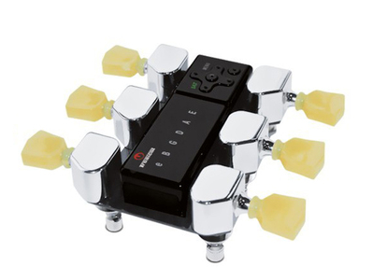

Figure 2 ‘Tronical Tune, Type I’ ([www.tronical.com](http://www.tronical.com), 2013)

The image shown in Figure 2 is a guitar tuner that tunes all 6 strings simultaneously. From my previous research into the difficulties found with tuning one string at a time, this appears to be the perfect solution to such a problem. If, for this project, a simultaneous tuner is chosen for the design, it will negate the problems with other strings going out of tune.

Although this seems like a good idea, with this technology comes new problems. First and foremost, the tuner must always be attached to the tuning knobs (machine heads) of the guitar. This means that the tuner is built-in to the guitar itself. Although this guarantees a robust and accurate tuner, it’s forgetting the original point of the tuner being easy to use, and being versatile. For this project, a tuner which can be easily used on any guitar at a moments notice is definitely preferable. Given the time and budget constraints, to undertake a simultaneous guitar tuner (with multiple signal inputs and multiple position control outputs) would not be feasible. It is however important to note: if such a simultaneous tuner existed for a floating tremolo bridge, it would absolutely be must-have for any high-end guitar users.

**2.4 Feedback loop & Motor specification**

Further to looking through existing products, the motion-control side of the project needed some research. In particular the ‘Motion control handbook’ (S O’Neil, 1998) proved very useful. This document covers both electrical and mechanical aspects of the control system. The section called ‘Building blocks of Programmable Motion Control Systems’ served as an overview of what needs to be done. O’Neil states ‘every programmable motion control system must have the foundation blocks: controller, amplifier, actuator, and feedback’. This is exactly what is fundamental to this project.

Further to this, his technical paper highlighted the necessity to specify the motor type correctly. There are many criteria that the motor must meet in order for the tuner to work correctly. It’s of utmost important to make sure the motor can overcome the torque required to turn any machine head of any guitar. This means the torque will need to be measured on a variety of different guitars with different string thicknesses, as the string thickness will greatly influence tension. For this reason as part of the methodology, an experiment will have to take place in order to correctly specify the motor.

**2.5 Literature research summary**

As far as literature research goes, some of the documents reviewed were more beneficial than others. This is mostly because during the project planning stage, the concept wasn’t so accurately realized, and therefore the research criteria was more general. For example – going back to the beginning of the literature search – documentation covering brushless motors (Leonard ,2012) and the differences between DC motors and stepper motors was reviewed. From this early research, up until the later research of the ‘motorized guitar tuner’ (Viehauser, M; Weißensteiner. R. 2012), the objectives have been put into perspective and the details of what is required to produce such a device have been fully realised. This information will be taken into account and ultimately will dictate a lot of the content of the Product Design Specification of this project.

**3 exPERIMENTAL / NUMERICAL /Design METHODOLOGY**

**3.1 INTRODUCTION**

In order to start such an ambitious electro-mechanical project, It was important to outline the individual steps required to begin the experiments and the simulation and eventually manufacture the first prototype. It was also important to follow the timing plan as best as possible given the availability of the laboratory and the equipment. To start off, a flow diagram was made outlining the key simulation objectives and indicating what needs to happen, in what order:

Figure 3

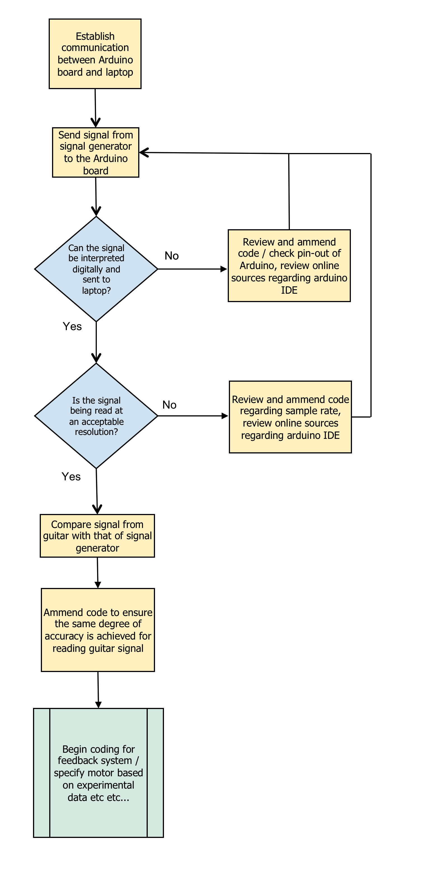

Work completed

Next steps…

**3.2 software selection**

This project is electro-mechanical, and so in order to create the closed loop electrical system, the choice of software needs to happen at this early stage. The most obvious system to use would be Matlab Simulink. This is the software used at Brookes University to simulate various electronic applications. There are three valid reasons why this software was not the preferred choice:

* The software needs to be written to the ATMAL AVR chip on the Arduino board. It would avoid any compatibility problems to use the software provided with the Arduino board and program it in it’s native programming language. This is referred to as it’s IDE, or integrated development environment, and it uses a code which is almost identical to C++.
* In order to use Simulink, all the simulation will have to happen on campus. Considering the work load, it would be more time-efficient to be able to work from multiple locations, and considering the software came with the Arduino package, using the IDE would be the best choice.
* Speaking from a programming language perspective, the IDE of the Arduino board is a ‘lower level’, meaning it’s closer to machine code than Simulink. It would be sensible to assume that the end goal could be more accurately achieved by investing the extra effort into programming in this language.

For the sake of the project, it might be an interesting point to try to program in both languages, however, due to the time constraint, it’s important to focus on the primary method at this time, this being the Arduino IDE.

**3.3 communicating with the arduino board**

To verify communications between the laptop and the Arduino board, a counter was programmed in the IDE of the Arduino. The output was read with ‘hyper terminal’ (windows-based serial terminal) to check the communications through RS232. This was used for debugging purposes. The output from the Arduino board is 5v and therefore not compatible with RS232. In order to convert the output of the Arduino to be compatible, and RS232 line driver chip (MAX 232CPE) was used to make the

**3.4 Reading the Signal (Input / output check)**

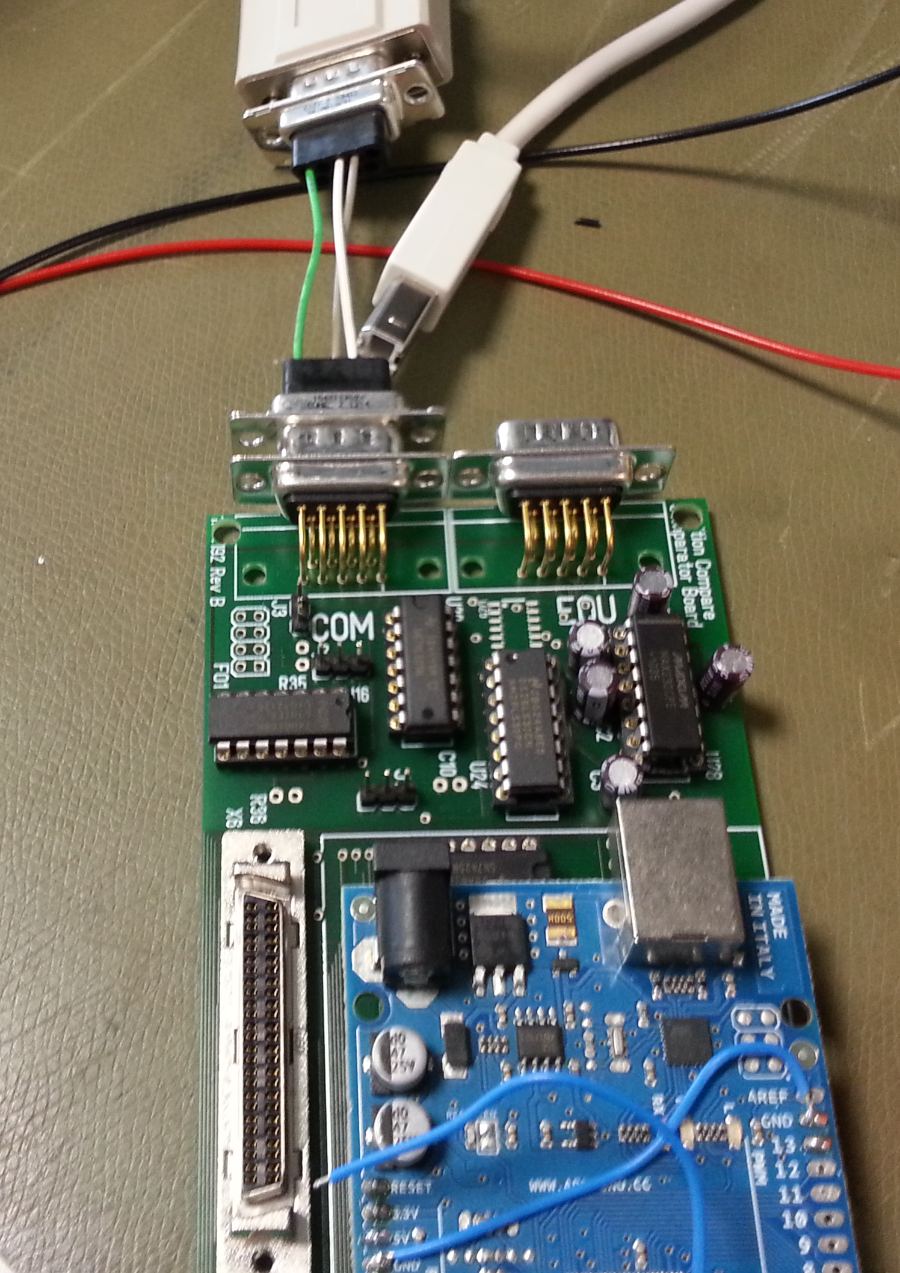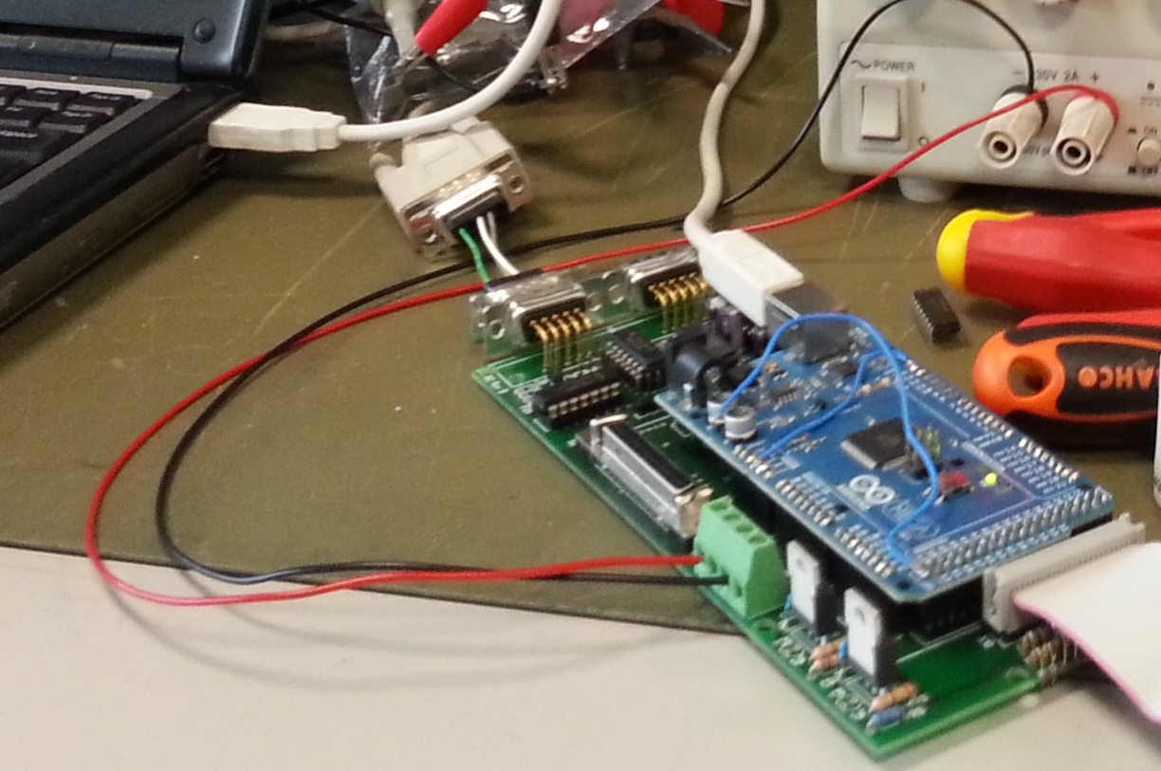

Fig.

Blue circuit board = Arduino board

Green circuit board = Contains line driver & RS232 port

Red circle = MAX232 chip

Fig.4

Pin 8 was set as an input for the Arduino board – this would be receiving the signal from the signal generator. Pin 9 was set as an output from the Arduino board – this pin was connected to the oscilloscope, so the signal can be measured from this with respect to ground. As the oscilloscope is now measuring the output, the RS232 circuit board was not needed.

The signal generator is sending a sine wave at a pre-determined frequency to the Arduino board (Pin 8). From pin 9 – which was set as an output – it could be seen that the same signal was correctly displayed on the oscilloscope, however the signal had now become as square wave as it is a digital representation of the analogue sine wave from the signal generator.

Fig 5 verifies that the analogue signal can be interpreted by the digital input of the Arduino board as a square wave for use in the software.

As can be seen, it’s now verified that the signals are the same frequency and that the input/output setup of the Arduino board is configured correctly.

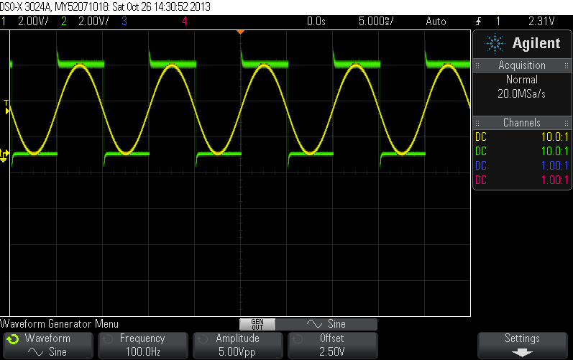

Fig 5

Fig 6 verifies that the Arduino board is interpreting 2.5v as being logic level 1.

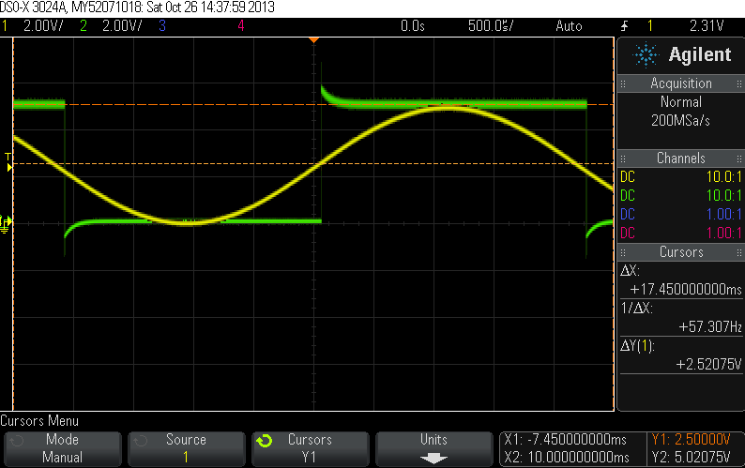

Fig.6

From these readings, the frequency can be determined. To determine frequency, the time period is measured from peak to peak. The frequency is the reciprocal of the period. In this case, the frequency of the signal is 222 hz.

[9 squares x 500micro sec = 4.5milisec 1 / 4.5milisec = 0.0045 = 1/0.0045 = 222 hz]

**3.5 coding the arduino board**

In order to ascertain that such a signal can be interpreted, Fig 7 shows the code that was created in order to mirror the input to the output. The text with the prefix of ‘//’ are notes made to help with understanding the code.

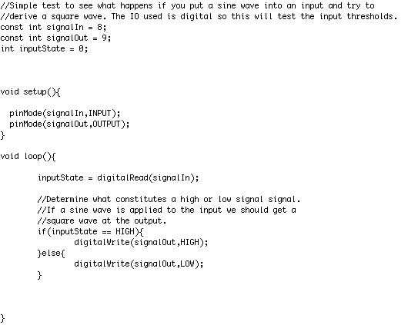

Fig. 7

The above code assigns pin 8 to be and input and pin 9 to be an output, this is done in the setup() method. The loop() method is executed continuously. In the loop() method the state of the input is continuously checked, and depending on its state, it writes to the output. i.e. if the input is on, the output is on. This way we are effectively mirroring the input to the output. As this input is a digital input which we are applying a sine wave to, we are actually determining the switching thresholds of the digital input. The above code should produce a square wave from a sine wave input of the correct amplitude (0V – 5V).

After having successfully read the analogue signal and interpreted it digitally, the next task is to ensure the frequency can be accurately determined. In order to achieve this, further coding is required to not only measure the time period, and thus determine the frequency, but also ensure that the reading is accurate to within 1hz. This was achieved through writing additional code which is included in Fig 8.

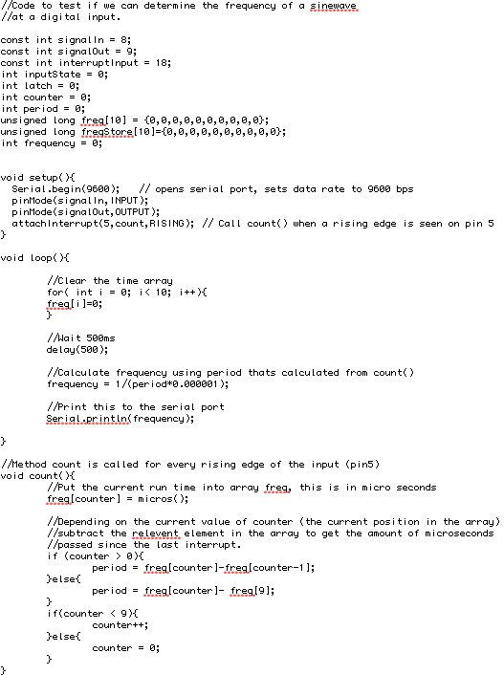

Fig. 8

The code in Fig. 8, was written to ensure the frequency of the input can be read within a reasonable degree of accuracy. As we are reading a frequency which a function of time we must do our best to ensure that the time taken to execute the code doesn’t effect our reading. In order to do this I have chosen to use an interrupt.

In the setup() method we have allocated pin 5 to be an interrupt and declared that when pin 5 goes high we will execute the method count(). When an interrupt is called it interrupts the standard flow of the program and executes the attached method as a high priority task. Interrupts are ideal for time critical tasks such as this. So, with this in mind the method count() is executed at the every peak of the sine wave input. This method calls a method in the arduino board called micros() that returns an integer that represents the number of microseconds the processor has been powered on, this is basically a high resolution representation of the current relative time. It puts this time into an array. It then increments a counter so that the next time this method is called the position the value is placed into an array is incremented. The method then subtracts the previous value in the array from the current value in the array. This essentially produces the time between the current peak of the sine wave and the previous peak of the sine wave, this is known as the period. There is also abit of code here that deals with wrapping round the position of the array, for example if we are at position 0 of the array we need to subtract position 9 from position 0.

The main part of the code executed in loop() simply clears the array, waits 500ms to allow the array to be filled by count() and prints the frequency out over the serial port. Frequency is given by 1/period.

With the above code running on the arduino we can inject a sine wave into the input at a know frequency from the signal generator. Then by reading the statements printed to the serial port we can confirm that the frequency of the input is correctly interpreted by the software.

**3.6 SUMMARY**

As this is an interim report, all the work in the methodology reflects what has been completed to date. In parallel with this work, additional work has been undertaken to design a 3d CAD representation of the product. This has been included as additional material in the appendix (Fig 15 & 16).

From the work completed so far, it can be said that only the first, but probably most important steps have been taken towards making the automatic guitar tuner. The techniques to detect frequencies accurate to 1hz have been achieved, and the next steps to be taken to make it work are fully realised (this can be seen in the section 4,‘Work in progress’).

From having completed a comprehensive literature search, the positive and negative features of different types of radial position controller have been noted and ultimately, influenced a decision of what kind of tuner will be made. This is where the PDS (Product Design Specification) comes in. From reading the literature and looking at the existing products, it is now possible to determine exactly what the aim of this project is, and – if this product was being made by an OEM - specify it in the PDS.

For a comprehensive list of requirements for the project, the PDS would usually be referred to. For the purposes of summarising however; the sources mentioned in the literature research have clarified the following necessary features of the project:

* The radial position controller will be coded in the arduino boards IDE, in a language similar to C++
* It must be designed to tune one string at a time
* During design, the fact that there’s a danger of making other strings out tune if a tremolo bridge is used, needs to be taken into account.
* The motor used to control the radial position must be a stepper motor
* The tuner must be accurate to +/- 5 cent (according to CR Nave, 2013) as the difference is almost impossible to detect by human ear.
* The device must be simple, needing as little human input as possible

**3.6 SUMMARY-continued**

From the work that has taken place so far, an accurate view of what is required has been determined and the methods of how to achieve it are known. Regarding the timing plan that was made at the beginning of the project; a lot of the milestones have been met perfectly. However, the development of the prototype has not met the initial milestone as set in the Gantt chart (refer to Section 5). The reasons for this are that the literature search took longer than expected and the creation of the supporting documentation also occupied a lot more time than was accounted for.

As can be seen in section 5, two elements of the Gantt chart have been changed since the initial planning stage. The deadline has moved back for the documentation, and also the prototype deadline was missed. Therefore a contingency was created and the timing plans updated

Contingency plan:

Because of the missed deadline for the prototype (as can be seen in Fig 11), the timing plan has been amended (Fig 12) to reflect a new allocation of timing. In order for this to work, there is now more of an overlap with the writing of the final report and the creation of the device. This seems to be the best way to achieve the end goal on time. This means that in parallel with the actual making of the product, the documentation will be being updated. This seems to be a more intelligent way of going about the project. As a result, the delivery date for the prototype has moved into 2014, but the end deadline is still the same.

A few sacrifices may have to be made as a result of this missed milestone, i.e. if a bespoke housing is to be made for the product, it will have to be CNC machined outside of Oxford Brookes University. This should not pose a problem, as there are many places that can do this kind of machining. Plus the aesthetics are less of a priority at this interim stage, as the functionality is the primary focus for now.

**4 work in progress and Completed**

So far the following has been completed:

1. Interpreted a sine wave using a digital input.
2. Determined the frequency of the sine wave at the input.

In order to apply the above to a guitar tuner the following tasks are foreseeable and will need to be completed. Undoubtedly other tasks required will become apparent as the project progresses and problems are encountered.

**1. Determine the frequency of a note generated from a real guitar:**

So far the frequency of a clean sine wave generated from a signal generator has been determined. Unfortunately the signal from a guitar may not be as clean. It will contain harmonics that are inherent in a signal that is generated from physical motion, and may also contain noise. We know that the frequency range of the open strings of a guitar is between 82Hz and 330Hz so we can design a crude low pass filter to remove the high frequency noise and harmonics. This will probably simply need to be a capacitor that has a low capacitive reactance at a frequency of, for example, 1kHz to be placed between the signal and ground. This would effectively short the higher frequencies to ground.

The amplitude of the signal may also be an issue. In order to exceed the high level input threshold of the arduino, the signal may need to be boosted or there may be a need to design some circuitry that interprets the signal using different thresholds. Fig 9, shows a circuit that may be suitable.

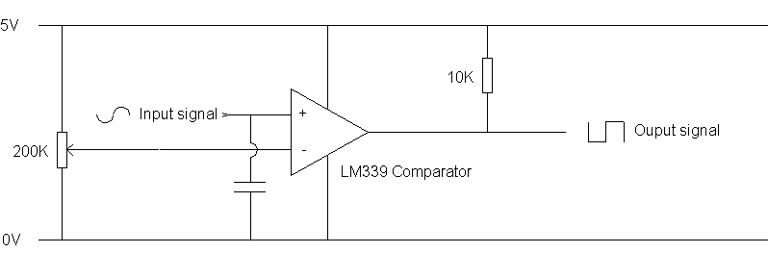

Fig 9. Example circuit to interpret guitar signal

Fig 9 is an approximate idea of what this circuit will probably look like. The 200k potentiometer determines the high-level voltage threshold. If the input signal exceeds this, the comparator will give a 5V output. This behaves like an adjustable Schmitt trigger.

**2.Determine the torque required to turn a machine head on a guitar and find a suitable motor / gearbox:**

This can be determined by using a torque wrench on the machine head. We need to know how many newton meters (Nm) it takes to turn the machine head to specify a suitable stepper motor. It is easy to obtain stepper motor / gearbox assemblies with significant gearbox ratios, so therefore it would probably be suitable to have a large gearbox and consequently substantially more torque than required. It is still worth measuring the torque required to ensure that we have a reasonable factor of safety above this. Using a high ratio gearbox would also give the added benefit a lower polar step displacement and hence higher resolution capabilities.

**3.Drive a stepper motor with the Arduino board**

There is already a stepper motor library available for the Arduino board on the Arduino website so the software side should be trivial. We will however need to implement some electronics to drive the stepper motor. This will just be a simple H-Bridge, as shown in Fig 10:

Fig 10. H-Bridge circuit taken from <http://arduino.cc/en/uploads/Tutorial/bipolar_schem.jpeg>

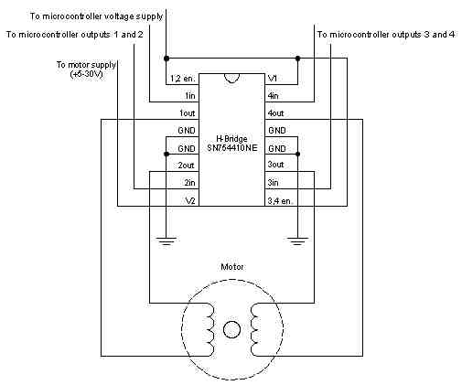

**4. Determine the ratio of stepper motor counts to change in frequency:**

In order to ensure we have the resolution needed to tune the guitar to within 1hz, the amount of steps required to result in a frequency change of 1hz needs to be determined. This will be done by creating a note on a guitar, measuring the frequency and turning the machine head to result in 1hz of frequency change. This may be impractical as 1hz may only require a very small rotation. To make this more practical and even more applicable, a geared stepper motor could be attached and tweaked in motor steps. This would give us our value in motor steps. As a rule of thumb, a step displacement of 10% of the smallest step size required should be aimed for, in this case 100mHz.

**5. Create a prototype of the hardware:**

Now that the torque and resolution requirements have been determined a suitable stepper motor and gearbox can be specified. Once this is done a prototype of the system can be designed and created. The prototype will be required to test the final functionality of the system.

**6. Implement a control loop in the Arduino:**

Now that the prototype has been completed and both an input device (guitar frequency) and an output device (Stepper motor) are present a control system can be developed and implemented. There are a few ways to do this, so some experimentation will be required to determine the best method. For example a full PID loop could be implemented, which adjusts the frequency to a frequency velocity profile, i.e. we generate a profile of how the frequency transitions between the start frequency and end frequency and follow that. This should give the best performance but may not be completely necessary; instead, an algorithm that tweaks in 1hz steps until the desired frequency is achieved could be used.

The control system will also need to decide what frequency to tune to, for example, if a string is plucked the system must determine which string has been plucked and therefore what is the desired frequency of that string.

With the above tasks completed the prototype should be functional. A final product can then be designed and fabricated. More tasks will come to light as problems are encountered.

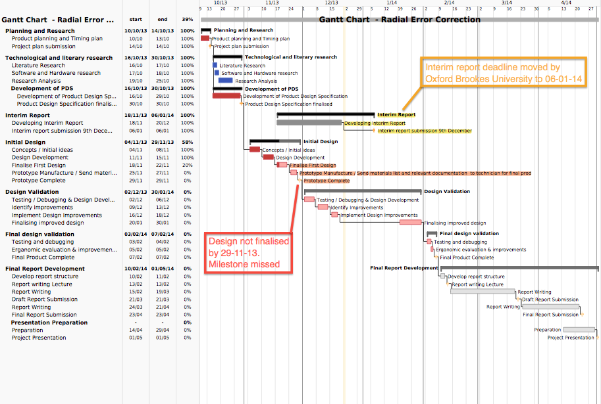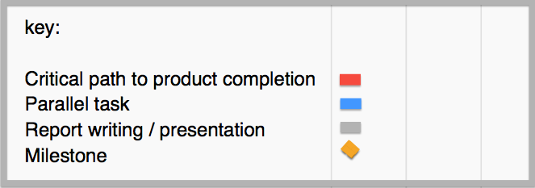

**Section 5 timing plan [fig 11]**

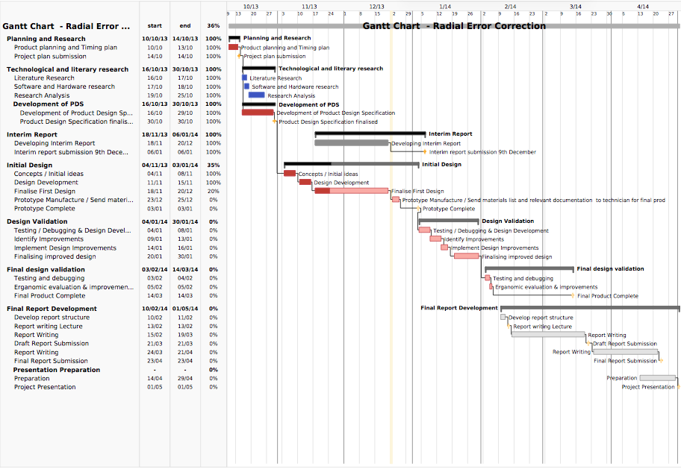

**Section 5 revised timing plan [fig 12]**



**6 SUMMARY**

In summary, a lot of work has been achieved up until this interim report. The project has been fully realised with achievable aims and reasonable time allocation. To review the progress made so far:

* A clear goal for the project has been defined with SMART Objectives
* A comprehensive literature search has helped define the requirements of the project further
* The Hardware / Software choices have been made based on what was found in the literature and what Oxford Brookes University have available
* The initial code has been written and verified to communicate with the chosen hardware
* The coding progressed to a point where the hardware is able to detect a sine wave and interpret the frequency
* The frequency resolution has been refined to distinguish differences of 1hz
* The concept of the housing of the project has been chosen
* The housing has been designed on CAD and will eventually be manufactured
* The next steps have been clearly defined, and parts for the prototype have been ordered
* The timing plan has been adhered to as closely as possible and revised to identify different time allocations for the second half of the project

The next steps of the project will take all the theory and use it to make the first prototype and eventually, the finished device. **7 REFERENCES**

* Nave, C. R. (2013). *Hyperphysics*. Available at: <http://hyperphysics.phy-astr.gsu.edu/hbase/hframe.html> (Accessed: 24th December 2013)
* O'neil, S. (1998). *Motion control handbook*. pp 1-38.
* Viehauser, R., Weissensteiner, M. (2012). *Motorized guitar tuner*. Dipl. Ing Telematics. Graz, University of Technology.
* Tronical GmbH (2013). *Tronical tune, type 1.* Available at: http://www.tronical.com (Accessed: 24th December 2013)**8 BIBLIOGRAPHY**
* Ahmed, M. S., Zungeru A. M (2012). *Development of a duel heater control system*. Development of a duel heater control system (2), pp. 127-136.
* Djaferis, T. E. (1998). *Automatic control: the power of feedback using MATLAB*. Boston: PWS Publishing.
* Dorf, R. C. (1998). *Modern control systems*. Harlow: Addison Wesley.
* Harbor, R., Phillips, C. L. (2000). *Feedback control systems*. 4th ed. London: Prentice-Hall.
* Maharem, A. N., Reseka, S. F., and Elsodany, N. M. (2010). Adaptive PID control of a stepper motor driving a flexible rotor. *Alexandria Engineering Journal* (50). pp 127-136.
* Newton, J. L. (2012). *Controlling a brushless motor*. BSc Engineering thesis. Oxford Brookes University.
* Nichols, N. B., Zeigler, J. G. (1942). *Optimum Settings for Automatic Controllers*. Transactions of the American Society of Mechanical Engineers (64). pp 759-768.
* Rizwan, M. (2009). *Controlling air driven motor with Arduino board*. BSEng thesis. Oxford Brookes University.

**9 APPENDICES**

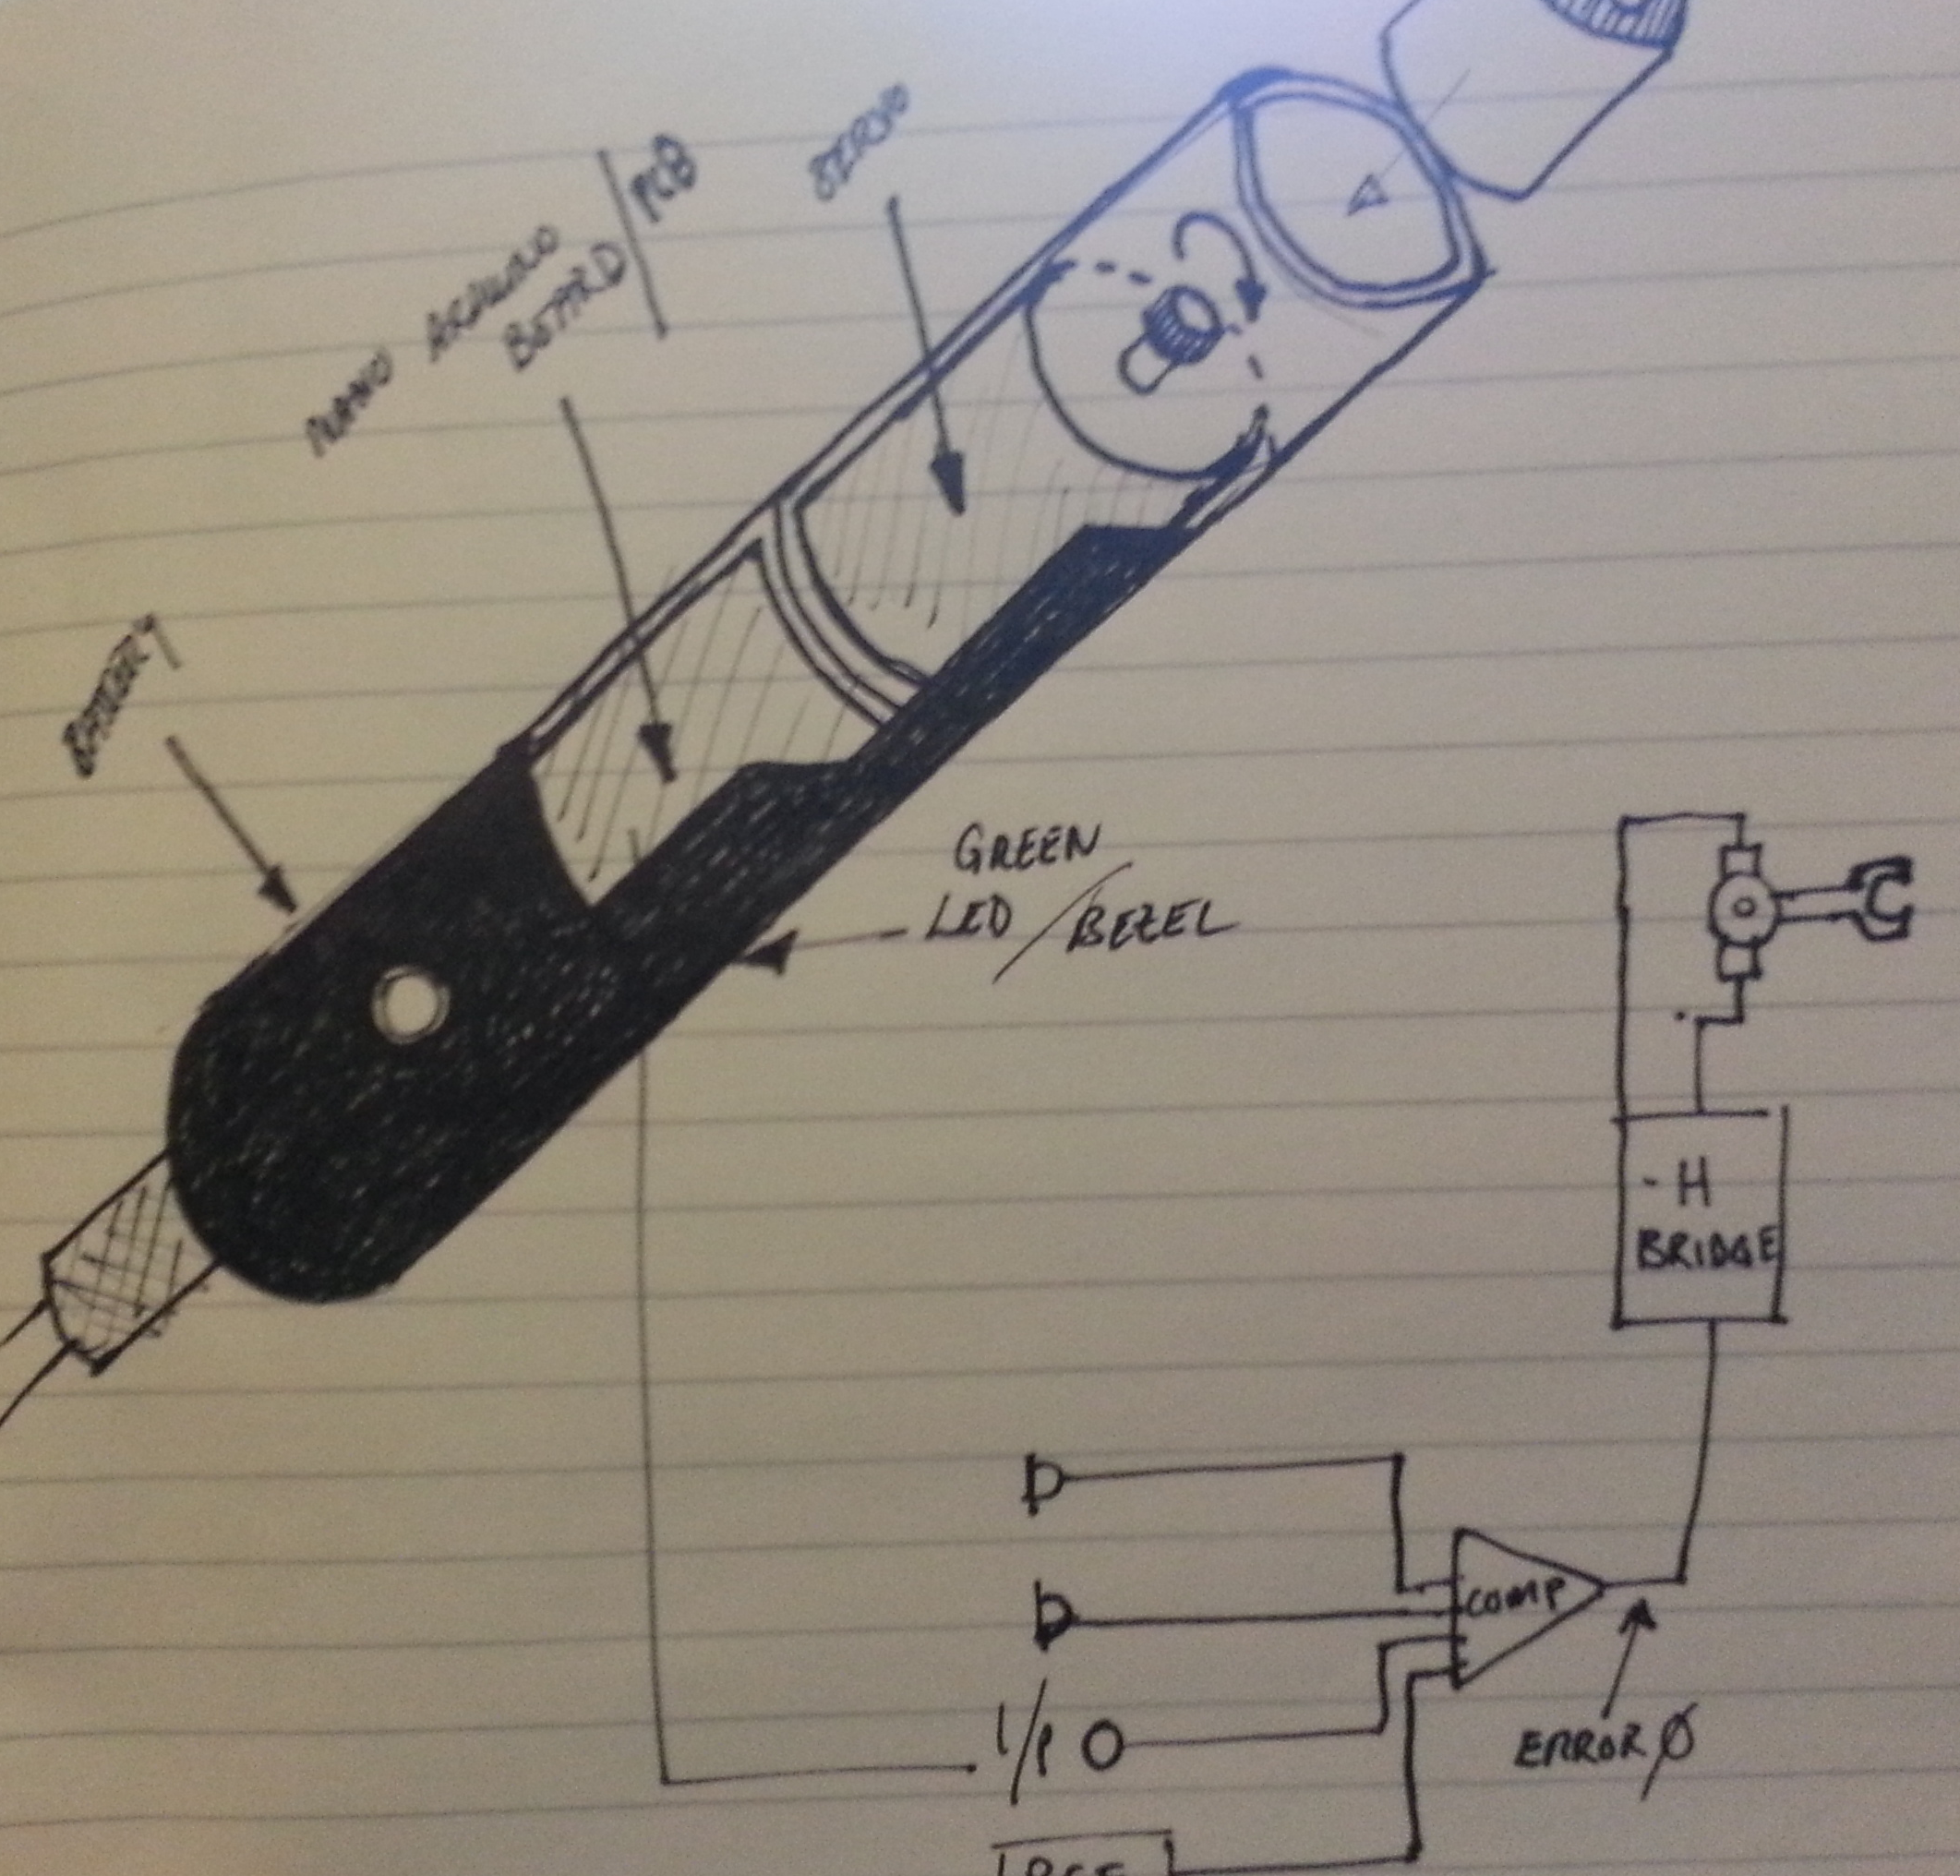

Fig 14 – detailed concept sketch of position controller housing

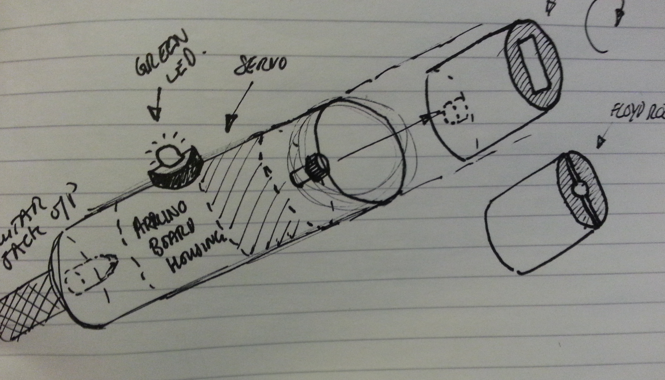

Fig 13 – Concept sketch of position controller housing

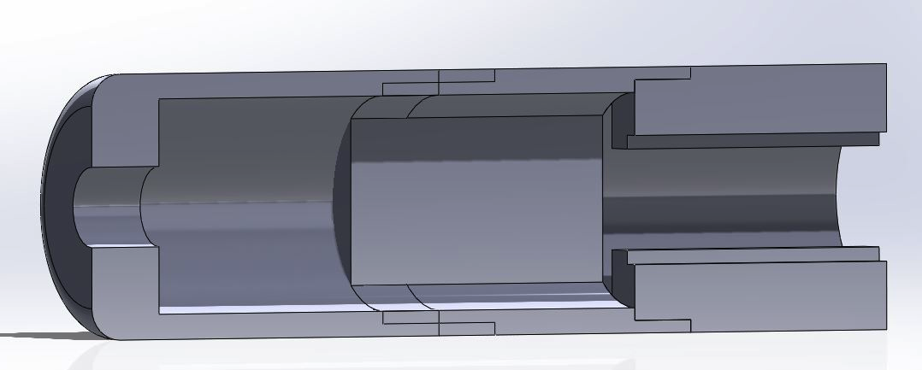

Fig 16 – Cross-section of device

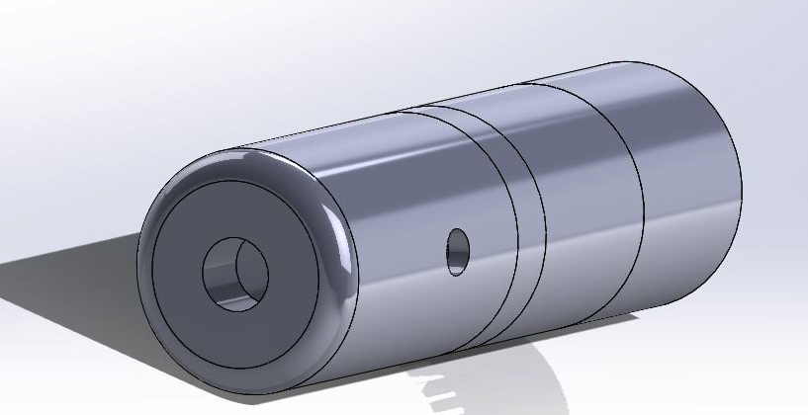

Fig 15 – CAD drawing of initial concept

**END OF DOCUMENT**